Lab 5: Copy-on-Write Fork for xv6
Laiba Irfan
31736
Screenshot pdf

(1) cowtest :

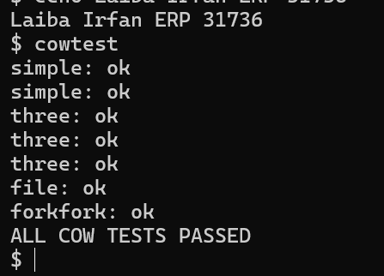

(2) cow_makegrade :



